Team 6570

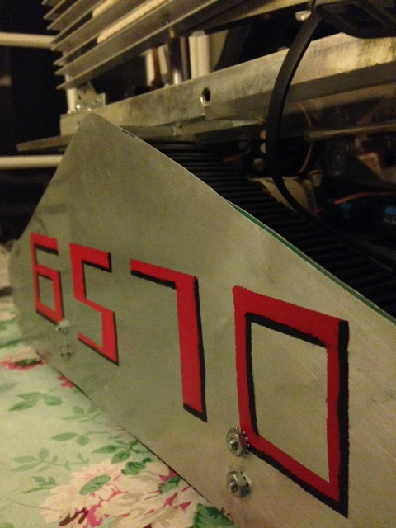

Pi-Radians

Team Bios

Esme Grundy – Team Captain

I am a senior. This is my 2nd year on the team. My hobbies include soccer and reading.

Tyler Teramae

I am a junior. This is my 1st year on the team. My hobbies include video games, and

Anthony Martinez

I am a junior. This is my 1st year on the team. My dream is to become director of the FBI.

Stephanie Nunez

I am a senior. This is my 1st year on the team. My hobbies include tumblr, and reading.

Ana Tovalin

I am a junior. This is my 1st year on the team. My hobbies include drumming, and programming.

Hannah Smith

I am a senior. This is my 2nd year on the team. My hobbies include drawing, and playing with my dogs.

Roy Kim

I am a junior. This is my 2nd year on the team.

Alex Kuznetsov

I am a junior. This is my 2nd year on the team.

Alejandro Lopez

I am a junior. This is my 1st year on the team.

Jason Morales

I am a junior. This is my 1st year on the team.

August 26, 2014

Attendance: